Student Non Academic Conduct and Disciplinary Policy
and Procedure

Students, as independent learners of Shockout Arts in partnership with the University of Bolton, are expected to behave in a mature and responsible manner. This policy and procedure are necessary to cover those occasions when a student’s behaviour and/or conduct falls short of these expectations.
- Purpose and Scope of the Policy and Procedure

  - The purpose of the Student Non-Academic Conduct and Discipline Procedure is to set out the standards of conduct and behaviour required to maintain and protect an environment conducive to learning and which is in keeping with the values of Shockout and the University of Bolton.
  - This policy and procedure do not cover Academic Misconduct, for example plagiarism, cheating, examination misconduct. However, if misconduct covers both Academic Misconduct and Non-Academic Conduct and Discipline both procedures may be considered concurrently.
  - Following the procedure ensures that disciplinary matters are dealt with promptly, fairly and consistently. The procedure gives guidance on how actions should be taken arising from misconduct.
  - By joining the Shockout and University of Bolton community, students agree to abide by all its policies and procedures and to adhere to the standards of behaviour specified within the policies and procedures which are set out on the website policy area, and which include, without limitation, the following:

- Academic Misconduct Regulations and Procedures
- Code of Practice on Postgraduate Research Programmes
- Examination Procedures
- Fitness to Practise Procedure
- Health and Safety Policy
- Library Rules and Regulations
- Mental Health Policy
- Policy on use of illegal drugs and misuse of legal drugs by students
- Prevent Policy
- Student Admissions Policy
- Student Attendance Policy
- Student Complaints Procedure

  - It is expected that, where appropriate, staff and students will seek to resolve matters informally before any formal disciplinary procedures are invoked. During the informal process the issues should be explained to the student clearly so that they understand the concerns and what the expectations are in order that the invocation of the formal procedure will be rendered unnecessary. Whilst this stage is informal to maintain clarity the outcomes of the meeting should be provided to the student in writing.
  - Should the required improvement not be forthcoming, or if the perceived problem is of a sufficiently serious nature, then the formal procedure as set out in section 6 of this document should be followed.
  - Where there is concern that the student’s behaviour and/or misconduct may be because of illness, mental health difficulties, psychological, personality or emotional disorders, the applicability of the Fitness to study policy.
  - If there are Fitness to Practice issues to be considered, the initial investigation stage (see Section 4) may require action to be taken to mitigate immediate risks to third parties e.g. patients, clients, and once the Disciplinary Procedure is completed the case may be considered under the Fitness to Practice Procedure.
  - Shockout and the University of Bolton has a duty of care to the students of and there may be occasions when decisions are taken to protect the interests of the student body.

- Variations to the Procedure

  - Shockout and the University of Bolton reserves the right to vary any stage in this procedure as it deems appropriate to comply with any current legal obligations and best practice.
  - Where mention is made in this procedure of action by specific post holder or role holder this action may be delegated to an appropriate nominee where warranted by the circumstances, for example, where there is or may be any potential conflict of roles or interests, or the specific post holder or role holder is absent, so long as the nominee has appropriate seniority and/or experience to be able to act on behalf of the specific post or role holder.

- General Principles

  - General Principles

    - In all cases the principles of natural justice will be applied
    - Information and formal meetings may take place in person or via remote telecommunications systems. When remote telecommunications systems are to be used, all parties are normally expected to activate their camera during the entirety of the meeting.
    - No formal disciplinary action will be taken against a student until the initial investigation stage has been completed. It is expected that minor issues of misconduct can normally be resolved informally between those involved either, student and student or student and member of staff
    - If criminal proceedings have been taken against the student, the disciplinary procedure will normally be suspended until the criminal proceedings are complete.
    - In the first instance it will be the duty of the Investigating Officer (as defined in paragraph 4.1) to decide, in consultation with principalship, whether and at what level the formal procedure should be initiated.
    - A student may be summarily excluded, i.e. excluded without notice, for serious misconduct normally after investigation and hearing.
    - A student shall have a right to appeal against any sanction issued because of disciplinary procedure as set out in section 8 of this procedure
    - A student will, at the formal procedure stage, have the right to be accompanied by a companion who shall not be a legal representative. If the student’s choice of companion is unreasonable the institution may ask him/her to choose someone else. For example:

- If in the institutions opinion the companion may have a conflict of interest or may prejudice the hearing; or
- If the student’s representative is unavailable at the date/time a hearing is scheduled and will not be available for more than five working days.

    - Only the Principal (or in the Principals absence the Principals nominee providing the nominee is a member of the Senior Leadership Team and they inform the Principal of the suspension so that he/she may affirm the action) shall have the right to suspend a student for misconduct or any good and urgent cause (see Section 5).
    - Only the Principal shall have the right to expel a student for misconduct or any other good and urgent cause.
    - Shockout or the University of Bolton in undertaking any aspect of this procedure will seek to make reasonable adjustments for students with a disability and refer to the Health, Wellbeing and Supported Study Policy where reasonable to do so.

  - Notice of Hearings

    - Normally ten working days’ notice will be given for disciplinary or appeal hearings. It is recognised, however, that this may have to be exceeded in exceptional circumstances.

  - Confidentiality/Recording of Meetings

    - Shockout and/or The University of Bolton aims during an investigation or any steps under this procedure to deal with matters sensitively and in confidence, to the extent that it can do so. All students will be required to treat as confidential any information communicated to them in connection with an investigation or disciplinary matter. Witnesses will be required to treat as confidential any information given to them during an investigation, including the identity of anybody under investigation.
    - Normally electronic recordings of any investigative meetings, disciplinary or appeal hearings are not permitted by any party or representative. Shockout and The University of Bolton will appoint a note taker to all formal meetings.

- Initial Investigative Stage

  - Where misconduct is alleged, an Investigating Officer will be arranged by the student’s Faculty to investigate and/or make enquiries to gather facts and information. An Investigating Officer may be any member of Shockout Senior Management Team or the University of Bolton staff at Grade 7 and above (excluding members of the Executive Board) and, as far as is reasonably practicable, will be unconnected to the case. The enquiries may include a fact gathering investigatory meetings with the student in question. This is for the purpose of fact-finding, and no decision on disciplinary action will be taken if appropriate until after a disciplinary hearing has been held. The student will be informed of the allegations and that an investigation is taking place.
  - A student involved in the investigatory stage is expected to cooperate fully and promptly and provide such assistance to the Investigating Officer as is required. This will include informing the Investigating Officer of the names of any relevant witnesses, disclosing any relevant documents to him/her and attending any investigative interviews. The student and any witnesses will be advised as to the sensitive nature of the investigation and the need for confidentiality.
  - The extent of any investigation and/or enquiry will depend on the nature of the allegations of misconduct and will vary from case to case.
  - The Investigating Officer, with the Senior Management Team/Head of School/Centre and/or Dean of Faculty, taking advice from the Principalship and/or the University of Bolton Standards and Enhancement Office as necessary, will determine if the investigation indicates that a formal disciplinary hearing is warranted, and if so the matter should proceed under the process set out at Section 6 below
  - In cases whereby the Health, Wellbeing and Supported Study Policy and Procedure is to be invoked this will form part of the investigation and will inform the actions to be taken and the student will be informed of this decision.
  - Where the investigation indicates that the matter may be dealt with informally or that no formal action will be taken the student and the relevant staff will be advised in.

- Suspension

  - Where the misconduct has resulted in criminal proceedings against the student or when the alleged misconduct is of such a nature that there are clear and compelling reasons or any other good and urgent cause why the student’s continuing attendance cannot be justified or where it is felt the student’s continuing attendance may hamper an investigation then the student may be suspended from studies by a member of the Principalship or Senior Management Team. The suspension will be confirmed to the student in writing.
  - The scope of suspension (if applied) will be at the discretion of Shockout and the University of Bolton on a case by case basis and will be to protect those involved in any alleged incident.
  - Suspension is not in itself a disciplinary sanction and does not imply that any decision has already been made about the student’s case. Normally during the period of suspension access to the VLE/Moodle and the student’s online Shockout and University account will remain available to the student.

- Formal Procedure

  - When a decision has been taken to initiate the formal disciplinary procedure, the student should be informed in writing of the decision to hold a disciplinary hearing and the individual who shall conduct the disciplinary hearing (“Disciplinary Officer”). The Disciplinary Officer will be a member of the Senior Management Team. Support for the Disciplinary Officer will be arranged by the student's Faculty. Such notice will also detail the allegations of misconduct that will be considered at the disciplinary hearing, clearly state the date, time and place of the hearing, and state the entitlement to be accompanied by a companion. The notice will also invite the student to inform the Disciplinary Officer of any reasonable adjustments that are required which will be accommodated where reasonably practicable. Reasonable time should be permitted for the student to arrange for the students representative to attend and for the student to prepare for the hearing.
  - At least 5 working days before the date of the disciplinary hearing (unless this is not reasonably practicable) the student should be provided with information and copies of any relevant documents and/or witness statements adduced as part of the investigatory stage that will be used at the hearing. In all cases where a witness’ identity is to be kept confidential, the student will be provided with as much information as possible in relation to the evidence provided by the witness in question, whilst maintaining confidentiality.
  - The student should attend the hearing. If the student cannot attend at the date/time specified he/she should inform the Disciplinary Officer immediately who will seek to agree an alternative date/time.
  - If the student does not attend the hearing without giving notice and/or without good reason the Disciplinary Hearing will be held and a decision made on the information and evidence available to the Disciplinary Officer.
  - The purpose of the disciplinary hearing is to review the evidence and to enable the student to respond to any allegations of misconduct that have been made against him/her. If the student is accompanied, that person may make representation and ask questions but should not answer questions on the student’s behalf. The student may request to confer privately with the student representative at any time during the hearing.
  - At the hearing the Disciplinary Officer will explain the process that will be followed and will confirm the allegations of misconduct. The case against the student will be presented, together with any supporting evidence. The student (or the students representative) shall set out his/her response, referring where appropriate to evidence.
  - The disciplinary hearing may be adjourned if the Disciplinary Officer deems that further investigations are necessary. The student will be given reasonable opportunity to consider any new information obtained before a disciplinary hearing is reconvened.
  - When the outcome of the Disciplinary Hearing is that the Disciplinary Officer has satisfied themselves based on evidence and on the balance of probabilities that the case against the student is proven, the Disciplinary Officer will determine what the appropriate disciplinary sanctions(s) should be.
  - The sanctions can include requiring the student to make restitution for any damage, theft or loss of property that he/she may have caused.
  - Where the recommendation from the Disciplinary Officer is expulsion, the recommendation will be considered by the Principal Vice for affirmation.
  - The Disciplinary Officer will confirm to the student in writing, usually within five working days of the hearing, the outcome of the disciplinary hearing including, where appropriate, the Principal’s affirmation of the recommendation of expulsion.

- Disciplinary Action and Expulsion

  - Shockout and the University aims to treat all students fairly and consistently. Each case will be assessed on its own merits. A non-exhaustive list of examples of what may constitute misconduct is set out in Appendix A. This is provided by way of guidance for the Disciplinary Officer.
  - Depending on the seriousness of the matter any of the following stages in paragraphs 7.3 to 7.4 may be omitted.

  - First Formal Action for Misconduct – Formal Verbal Warning

    - A verbal warning will normally be given for first acts of misconduct where there are no other active warnings on the student’s disciplinary record depending on the nature of the misconduct.
    - The warning will set out the nature of the misconduct.
    - The student may be required to give a written undertaking as to his/her future conduct.
    - The student may be required to make restitution for any damage, loss and/or theft they have caused by the misconduct.
    - A record of the warning will be placed on the student’s record and will remain active for six months from the date it is given, after which time it will be disregarded in deciding the outcome of future disciplinary proceedings. The student’s conduct may be reviewed at the end of this period and if it has not improved sufficiently Shockout and/or the University may decide to take further disciplinary action.

  - Second Formal Action for Misconduct – Written Warning

    - A written warning will normally be given for acts of misconduct where there is a record of a verbal warning or where there are no other active warnings on the student’s disciplinary record depending on the nature of the misconduct.
    - The warning will set out the nature of the misconduct.
    - The student may be required to give a written undertaking as to his/her future conduct.
    - The student may be required to make restitution for any damage, loss and/or theft they have caused by the misconduct.
    - The warning will be placed on the student’s record and will remain active for remaining period of their registration at Shockout in partnership with the University of Bolton, after which time it will be removed from their student record.

  - Final Formal Action for Misconduct – Expulsion

    - Students may be expelled for the following circumstances:

    - Misconduct where there is an active written warning on the student’s record;
or
    - Serious misconduct regardless of whether the student has received any previous warnings.

    - A decision to expel a student may only be taken by the Principal or the University of Bolton’s Vice Chancellor and will be with immediate effect with cessation of any contractual obligations thereafter. A student who is expelled continues to be liable for any outstanding fees.

- Right of Appeal

  - In the letter confirming the outcome of the disciplinary hearing, the student will be notified of his/her right to appeal.
  - An Appeal is heard by an “Appeal Officer”. The Appeal Office will be supported by a member of the Senior Management Team.
  - When an appeal is against any disciplinary sanction other than expulsion, the Appeal Officer will be a member of the Senior Management Team who has not had any previous involvement with the case, as far as is reasonably possible.
  - When an appeal is against expulsion, the Appeal Officer will be the most senior member of the organisation (or their nominee in the event of their unavailability).
  - A request for an appeal should be lodged in writing within five working days of written notification being sent to the student of the outcome of the disciplinary hearing. The request for an appeal should be submitted on the Non Academic Conduct and Disciplinary Outcome Appeal Form (See appendix C) and should state the full grounds for the appeal. The grounds may be:

- There was a procedural irregularity in the conduct of the Disciplinary Panel or the investigation that may render the original decision unsafe;
- New material evidence is available which the student was unable, for valid reasons, to provide earlier in the process and which may have resulted in a different outcome;
- The outcome (whether the decision or sanction) was unreasonable.

  - The Senior Leadership Team and Principalship will determine if the request for an appeal is to be permitted or is to be rejected based on the grounds that the student has identified and the student will be informed of that decision in writing. If the appeal is rejected the letter explaining the reasons why will also be the Completion of Procedures Letter which indicates that the internal procedures have now been completed.
  - If the appeal is permitted, the student will be notified in writing of the arrangements for the appeal, whether the appeal will be considered by the written submission or at a hearing, and his/her right to be accompanied at a hearing by a companion. The notice will also invite the student to inform of any reasonable adjustments that are required which will be accommodated where reasonably practicable. When an Appeal Hearing is to be held, it will be held where possible within ten working days following receipt of the request. Any new supporting evidence that will be considered at the appeal hearing should be provided by all parties no later than five working days before the appeal hearing
  - The student should attend the hearing. If the student cannot attend at the date/time specified he/she should inform the institution and investigating officer immediately who will seek to agree an alternative date/time.
  - If the student does not attend the appeal hearing without giving notice and/or without good reason the hearing will go ahead and a decision will be made by the Appeal Officer based on the information and evidence available to him/her.
  - At the appeals hearing records and notes from the disciplinary hearing and any new evidence will be made available to the Appeal Officer who will review the evidence. Any new supporting evidence that will be considered at the appeal hearing should be provided by all parties no later than five working days before the appeal hearing.
  - When the outcome of the Appeal Hearing is that the Appeal Officer has satisfied themselves based on evidence and the balance of probabilities that the case against the student remains proven, the Appeal Officer shall confirm that the disciplinary sanction(s) should be upheld or amended.
  - When the outcome of the Appeal Hearing is that the Appeal Officer has not satisfied themselves based on evidence and on the balance of probabilities that the case against the student is proven, the Appeal Officer will determine what the disciplinary sanctions(s) should be revoked or amended.
  - he student will be informed of the outcome of the appeal in writing normally within five working days of the appeal hearing. The appeal process is the end of the University’s internal procedures and the Appeal Outcome Letter will also be the Completion of Procedures Letter
  - There is no further right to appeal and the internal procedure is exhausted at this stage.
  - In circumstances where the Appeal Officer determines to uphold an appeal by a student:
    - In the case of verbal or written warning being given the warning will be removed from the student’s record;
    - In the case of expulsion, the student’s status will be reinstated from the date the expulsion took effect and the student will not be deemed to have had any break in their studies.

- Completion of Procedures and the Office of the Independent Adjudicator
  - In the letter confirming the outcome of the appeals hearing, the student will be notified that the letter is also the Completion of Procedures Letter and will include his/her right to request an independent review by the Office of the Independent Adjudicator.

- Keeping of Records

  - Records of the disciplinary case will be kept for the period of the active sanction and comply with relevant statutes and will be destroyed thereafter. These records will normally include the complaint against the student, the student’s defence, findings made and action taken, the reason for action taken, whether an appeal is lodged and the outcome. Notes of any formal meetings will also be kept.

- Other Related Policies

  - Other related policies can be found on the policy section at www.weareshockout.com and upon the University of Bolton Student Information Policy Zone.

- Monitoring and Review

  - This procedure will be monitored and reviewed annually. The outcome of such monitoring and review updates will be published on an annual basis.

- Equality Impact Assessment

  - Shockout and the University of Bolton is committed to the promotion of equality, diversity and a supportive environment for all members of our community. Our commitment to equality and diversity means that this policy has been screened in relation to the use of plain English and the promotion of the positive duty in relation to the protected characteristics of race, sex, disability, age, sexual orientation, religion or belief, gender reassignment, marriage and civil partnership, pregnancy and maternity.

- Dissemination of and access to the Policy

  - This policy is published on the Shockout Arts website alongside any related policy. In addition further related policies from the University of Bolton are located upon the Student Information Policy Zone and on the University of Bolton Governance website.
Appendix A
An illustrative, non-exhaustive list of unacceptable behaviours and conduct
The aim of this appendix is to give illustrations, which are not exhaustive, of behaviours and conduct which will normally be deemed to constitute serious breaches of discipline for the purposes of this Policy, whether expressed orally, in writing or electronically, occurring on Shockout or University of Bolton premises or elsewhere, including social networking/media sites, blogs, websites or other media. In investigating the circumstances surrounding a particular incident, and being presented with any other mitigating factors, the institution(s) may choose to impose sanctions less than those outlined in this appendix.
Sanctions which warrant expulsion from the institution(s) for the first breach are considered to be examples of serious misconduct.
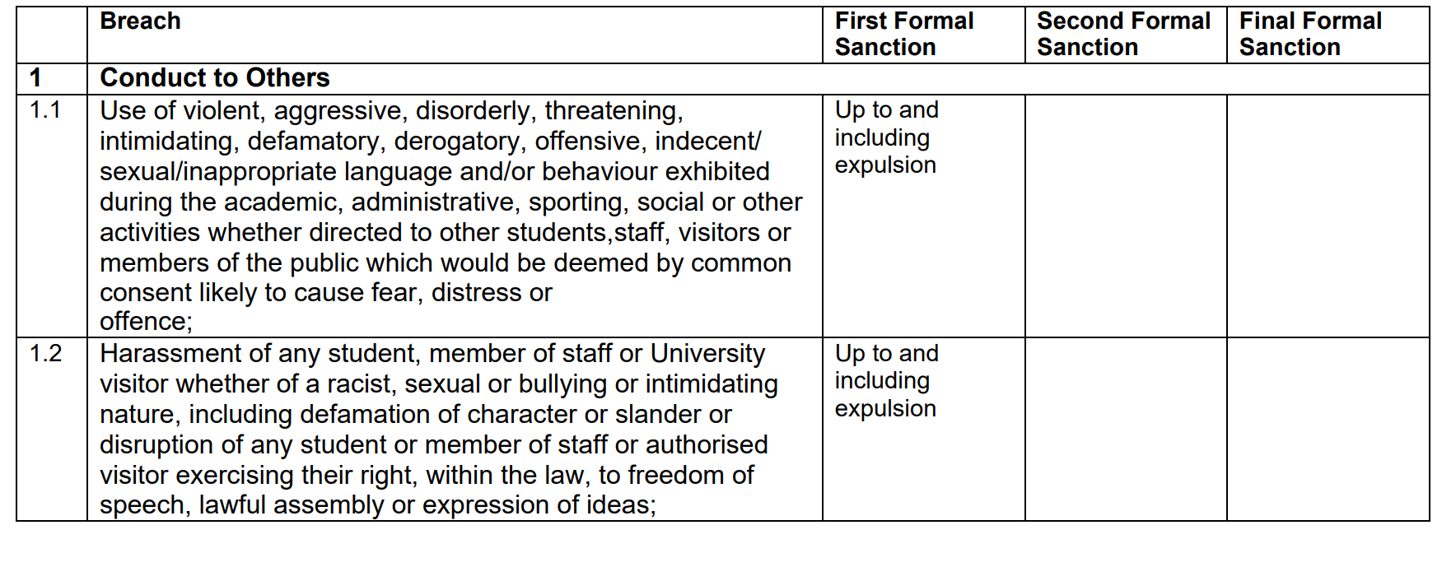

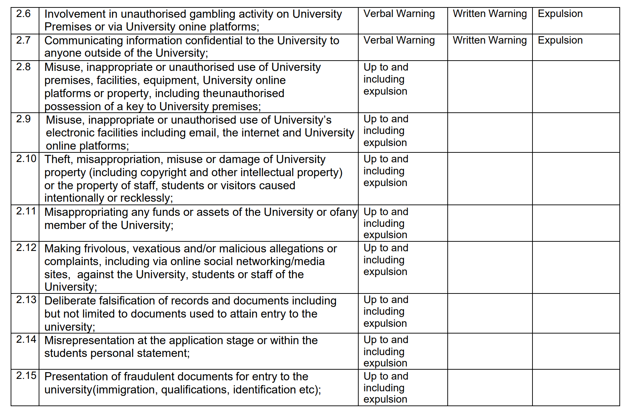

SHOCKOUT
STUDENT NON-ACADEMIC CONDUCT AND DISCIPLINARY DECISION APPEAL FORM
This form is to be completed for appeals to be dealt with under the Student Non-Academic Conduct and Disciplinary procedures. This request for an appeal should be sent to complaints@weareshockout.com within five working days of the written notification being sent to you of the outcome of the disciplinary hearing.

DETAILS OF APPEAL – TO BE COMPLETED BY STUDENT
Name: | Student Number:
Programme: | Year of Study:
Date of Hearing: | Date of Outcome Letter:
Information for correspondence in connection with your appeal:

Student email:

Personal email:

An appeal can only be submitted on one or more of the following grounds. Please indicate the ground(s) for your appeal by ticking the appropriate box.
A. There was a procedural irregularity in the conduct of the Disciplinary Panel or the investigation that may render the original decision unsafe
B. New material evidence is available which the student was unable, for valid reasons, to provide earlier in the process and which may have resulted in a different outcome
C. The outcome (whether the decision or sanction) was unreasonable
in relation to the ground(s) you have indicated above (A, B or C), please explain for each relevant ground why you are dissatisfied with the decision or penalty at the previous stage of the Procedure.
If appealing under Ground A – Procedural irregularity. Please explain clearly in the box below why you believe that there was an irregularity in the conduct of the Disciplinary Panel or the investigation and how you believe this has affected the outcome of the hearing - include relevant documents with your submitted appeal, or indicate ‘to follow’ with timescale for their availability
If appealing under Ground B – New information. Please explain clearly in the box below why this was not available at an earlier stage of the process and the relevance of the evidence to your appeal - include relevant documents with your submitted appeal, or indicate if the item(s) are ‘to follow’ with timescale for their availability
If appealing under Ground C – Outcome unreasonable. Please explain clearly in the box below why you believe the outcome of the panel was unreasonable
Request for an extension to acquire further information: Should you require further time to acquire additional documentary evidence you can make a request here. To do this you must state:
• the precise nature of the documentation to follow,
• the grounds for appeal it relates to,
• the reason that it is not currently available,
• the date by which you will be able to submit the document.
Please provide details below:

Declaration (you must complete this section)
I declare that the information given in this form is accurate, the supporting evidence is genuine, and that I have read and understood the relevant Procedures.
Name: | Date:

